

AI Assisted Problem Solving Using Python

AcademicYear:2025-2026

Assignment Type: Lab
Assig_No. 4

Submitted by:
Name: Nukala Meghana Sri
Enrol No. 2503B05113
Course: M-Tech CSE

Submitted to:
Name: Venkataramana Veeramsetty
Title: Course Instructor

Date: 3 NOV 2025

Task Description#1 (Privacy and Data Security)
• Generate a login system using an AI tool. Analyze if the AI inserts hardcoded
credentials or insecure logic.
Expected Output#1
• Description of risks and revised secure version
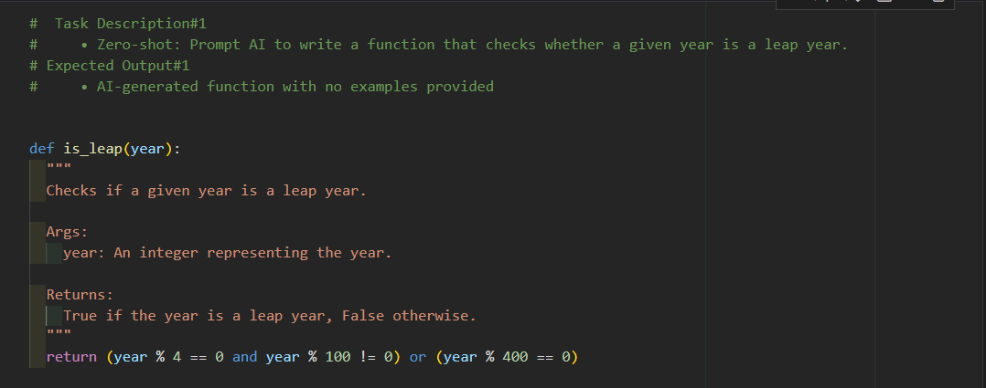
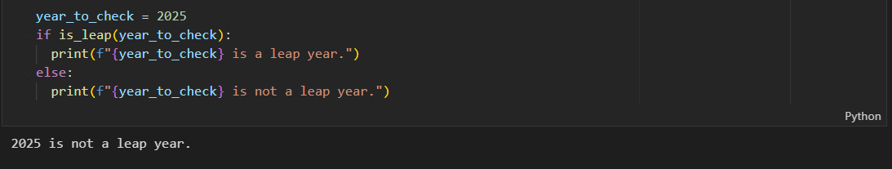
Task Description#2
● One-shot: Give one input-output example to guide AI in writing a function that
converts centimeters to inches.
Expected Output#2
● Function with correct conversion logic

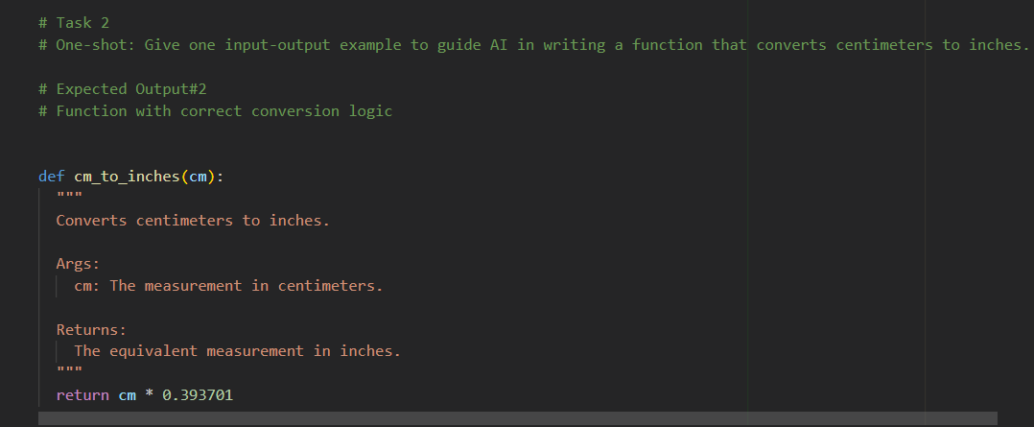
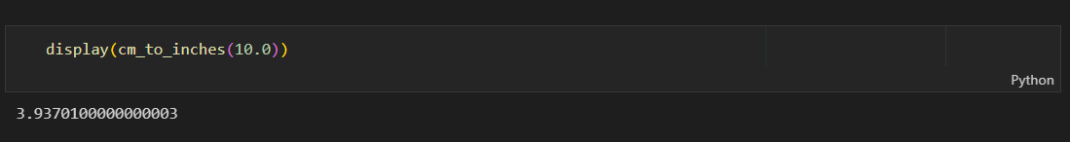
Task Description#3
● Few-shot: Provide 2–3 examples to generate a function that formats full names as
“Last, First”.
Expected Output#3
● Well-structured function respecting the examples
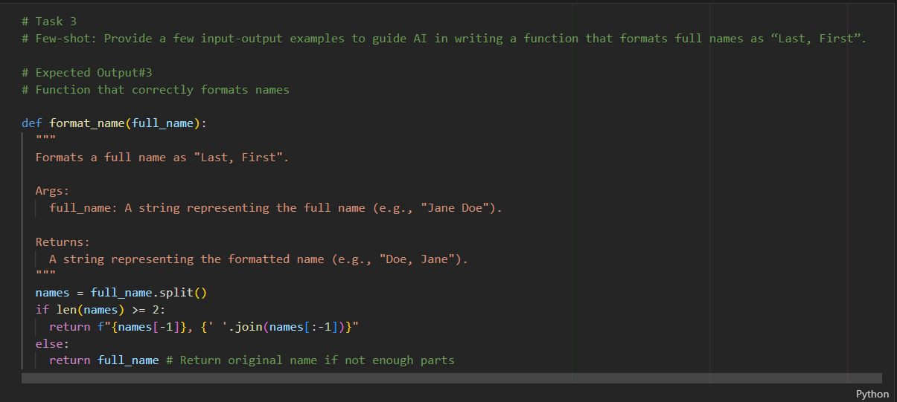
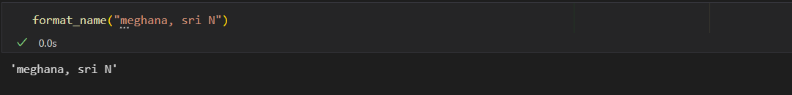
Task Description#4
● Compare zero-shot and few-shot prompts for writing a function that counts the
number of vowels in a string.
Expected Output#4
● Functional output and comparative reflection
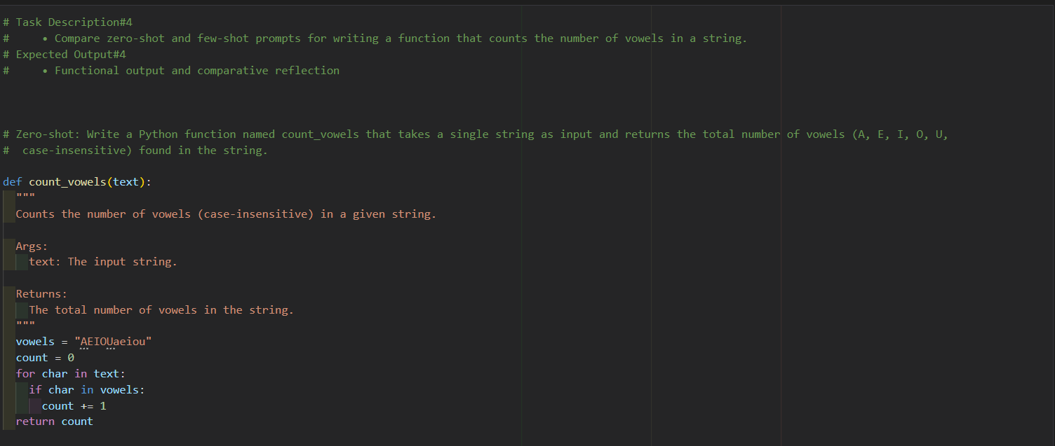
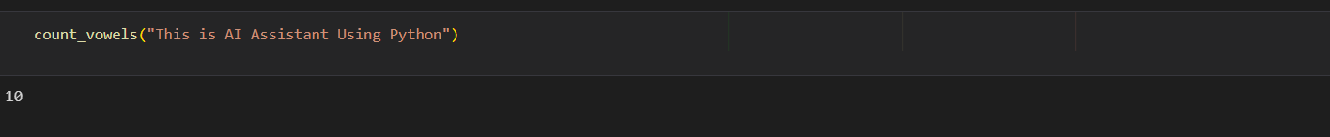

Task Description#5
● Use few-shot prompting to generate a function that reads a .txt file and returns the
number of lines.
Expected Output#5
● Working file-processing function with AI-guided logic
